1 ) SELECT DISTINCT joining_date FROM developers ORDER BY joining_date ASC;

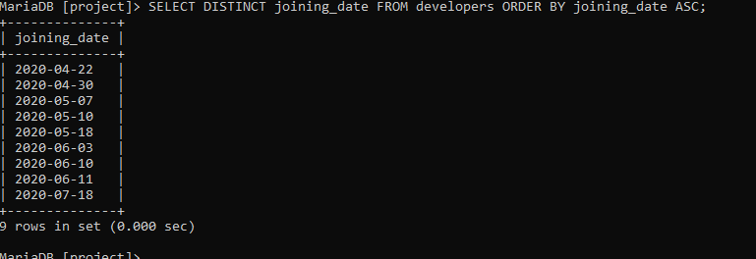

2 ) SELECT name,email,followers FROM developers ORDER BY followers DESC LIMIT 5;

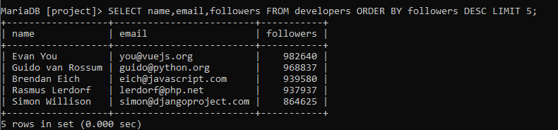

3 ) SELECT multiplier, COUNT(*) as total_developers FROM developers GROUP BY multiplier;

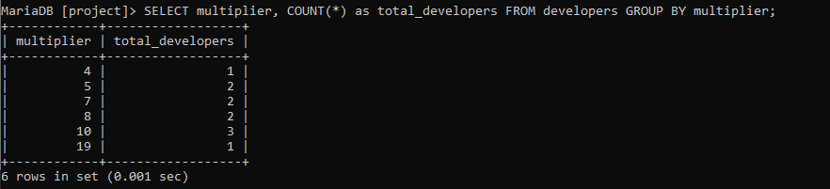

4 ) SELECT name, multiplier FROM developers WHERE multiplier = ( SELECT MAX(multiplier) FROM developers WHERE followers < 700000 ) and followers < 700000;

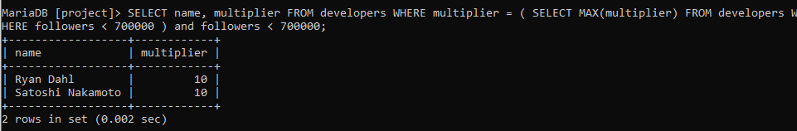

5 ) SELECT AVG(followers) as average_followers FROM developers WHERE joining_date < "2020-06-11";

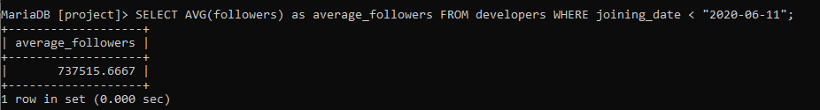

6 ) SELECT member_id,name,email,followers FROM developers WHERE email like "%.com" or email like "%.net";

